2D SPIFI Research Proposal

Brennan W. Fieck

October 25, 2016



Introduction

The basis of the broader project to which this team’s efforts contribute is to expand upon an existing technology called Spatial Frequency Modulated Single Detector Imaging (SPIFI). Currently, the technique is used to scan small objects in order to provide high-resolution imaging of those objects. The next step is to enable the system to scan the object much faster by eliminating the current need to scan over a diffraction grating by implementing a larger diffraction grating that need not be scanned. This team’s project is primarily to provide simulation software to compare the output predicted by an ideal system to actual data collected from these systems once they have been constructed, and to produce a software suite for collecting, analyzing and visualizing the output of implementations of 2-dimensional SPIFI systems.

Background

SPIFI is a revolutionary imaging technique that allows an object to be scanned by a single laser. In particular, it is impressive because a full, two- dimensional image can be extracted from light collected at a single point. Traditionally, this would require multiple collectors to be able to resolve which photons were used to scan what part of the object (e.g. using a cam- era). SPIFI enables scientists to scan objects with one collector (and without alternatively using a raster pattern to scan each part of the object sequen- tially) by encoding this information in a frequency change that maps directly to a plane normal to the laser’s direction of propagation. Figure 1 shows a visual depiction of this; each inscribed ω is unique to the section of the x/y plane that bounds it. This is a low-resolution simplification, of course, but the result is the same. Up to some resolution, every point in the x/y plane can be uniquely identified by the frequency associated with it. Thus, the light can be recombined back into a well-collimated laser beam and directed at a single point of detection without losing position information. The mapping is resolved after detection by simply taking a Fourier transform of the intensity incident on the detector (the de- tector transforms this linearly into a voltage) and determine which areas of the plane were ”impeded” by looking for drops in the intensities of individual frequencies. In an ideal situation where diffraction from the optics appara- tus is ignored, a simple SPIFI system can be modeled by Figure 2. Each

component that modifies the oscillation function that represents the electric field of the laser is labeled with a function of x, y, and t, continuing the con- vention that the laser propagates in the zˆ direction1. Again, assuming ideal conditions, these transfer functions can fully describe the signal’s output at the detector. Specifically, the output has the form

Iout = |E0 u[x, y] m[x, y, t] g[x, y]|

2

(1)

where E0 is the amplitude of the initial electric field of the laser. Of course, electromagnetic waves vary in time as well as space. However, because the lasers used will produce photons that are in-phase with one another for any given value of z, this oscillation applies to all frequencies produced by the SPIFI grating equally, and in any case does not affect intensity in any way; thus in can be trivially eliminated it from the calculations. The transfer func- tion u[x, y] represents the initial form of the laser before it passes through any apparatus, and it takes the same form as a traditional wave oscillation. The transfer function g[x, y] is determined by the object being imaged, and represents a lowering of amplitude of specific sections of the x/y plane based on the object’s ability to absorb and reflect light, usually directly propor- tionally to the object’s thickness in that section. There is not really a good way to model this as a mathematical function in a general case, and in any event it is the unknown quantity in the system. The function m[x, y, t] is the transformation applied by the SPIFI grating, and its form depends on the pattern used. Examples of typical gratings are shown in Figure 4. For the common circular grating - similar to the one in the Figure 4-, the form of the pattern in polar coordinates is

pattern[r, t] =

1 1

2 + 2 cos [2πfm kp rt] . (2)

Here, fm is the rotational frequency of the grating, and kp is a constant that has to do with the density of the lines in the pattern. As shown in Figure 5, this modulates the laser as it passes through the grating as a line, and then is scanned along the object from top to bottom by some optics equipment. Thus a transformation from 2 to the m[x, y, t] transfer function requires sampling the output in intervals of τm = 1/fm , the period of the pattern’s spinning.

1 In Figure 2 the laser changes direction. This applies no transfer function other than this change in direction, and thus the system can be considered equivalent to one which does not change direction for mathematical purposes.

Once the light has been scanned over the object, the intensity recorded by the detector during τm can be Fourier-transformed to find the contributions from each frequency at a given time. In other words, 1 represents the intensity of a specific horizontal line on the object, and the time-domain and frequency-domain plots of this for some unknown object looks like Figure

6. Given that the forms of m[x, y, t] and u[x, y] are known, the form of g[x, y] can be obtained (and equivalently the shape of the scanned object) by comparing the contribution of each frequency produced by the SPIFI grating to what it would be if g[x, y] were always 1.

Theory

The focus of this project is to expand the capabilities of SPIFI by using a diffraction grating which, unlike those presented in the Background section, diffracts the entire beam in two dimensions at any one time, thereby eliminating the need to scan the laser beam along the object. Because this will allow scanning of the object to occur all at once, there is no need to accu- mulate readings over some time interval, and therefore real-time imaging is made much easier. A basic, somewhat crude example of a circular grating that could be used is presented in Figure 7. Keep in mind, this is only meant to show how the 2-dimensional diffraction gratings might be mounted on a wheel to modulate the laser beam. Figure 8 shows a low-density, possible pattern for one of these squares. At the time of this writing, the idea for this tech- nology is little more than a week old, and only one of these wheels has been produced and tested2, so images of a real, working grating wheel are unavailable. The team’s job will be to first construct a working simu- lation of one of these wheels given a wheel pattern, then to create a data collection routine for this new system- either from scratch or by modifying existing code written by the SPIFI team.

2 Imaging has not yet been performed; testing merely served to ensure that the wheel could be mounted and would not cause any unforeseen mechanical issues

Statement of Work

Our team is tasked with developing simulations of 2-dimensional SPIFI systems and with writing data collection software. Each task will occur in increments, and each will require a report as well as documentation.

Firstly, the simulation will be built up in the following steps:

1. An ideal simulation using a perfectly continuous grating wheel

2. Incorporate gaps between patterns on the wheel

3. Incorporate refraction and diffraction caused by equipment

Documentation for this program will be made available in exhaustive pdf form as well as POSIX-compliant manual pages for the first incarnation, and subsequently updated for each change. The program will be written in an open language standard (C) using a free and open runtime for that language (the GNU Standard C library, compiled using the GNU C Compiler), and will be written and run on existing computers.

Secondly, data collection software will be written in the following two steps:

1. Analysis of existing codebase

2. Development of actual software

Data collection software already exists for simple, 1-dimensional SPIFI sys- tems, so it may be advantageous to build the 2-dimensional analysis tool by writing a new version of this suite, or even to simply add it directly into the existing structure. Alternatively, if the current software is found to be de- void of functionality that can be used for the new system, or if it is deemed too bloated, slow, or incapable of interfacing properly with the detection hardware in some way, it would be more prudent to begin a new program and build it from the ground up. To decide which is better, the existing code will be analyzed, ideally in collaboration with the original team that wrote it - a coalition of researchers and research assistants from the Colorado School of Mines and the University of Colorado in Fort Collins, with the latter currently in charge of maintaining and updating. Af- ter the analysis, the actual code will have to be written. Whatever decision

is reached regarding the use of the 1-dimensional analysis software, the final product will be written in an open language standard, and utilize a free and open runtime. 3 However, the current software is packaged as ”Solutions” for the Microsoft IDE and Development Environment called Visual Studio. Therefore, even if neither of these codebases is used, Visual Studio must be used in their analysis. Not only is Visual Studio itself not free, it only runs on the proprietary operating system Windows version 7 or higher. Furthermore, the company Jet Brains produces a proprietary plugin for Visual Studio that makes working with C# so much easier, and consequentially saves developers so much time that the vast majority of companies that work with C# deem it worth the cost. Given this, and the fact that the head software engineer is already familiar with the plugin, it would be very difficult to complete the analysis of the existing data collection software inside of the estimated timeframe - certainly not with the 10 h/week estimate - without the use of the plugin.

Now, perhaps, Statement of Work

A breakdown of these costs is given in Table 1, and a timeline given for these tasks and their various parts; in addition, the report to be presented on completion is given in Table 2 and the data is visualized in Table 1. Labor cost estimates are based on a rough $44.00/h starting pay for software engineers, equivalent to $440.00 per 7 days or about $63.00/day, assuming I spend 10 h/week (standard part-time employment hours/week) working on these tasks.

In short, the team requests $17,552.00 to complete this project.

Conclusion

The ability to reliably simulate 2D SPIFI systems is crucial to the ability of the other teams working on the broader project to ensure the diffraction patterns, wheel designs, and optical systems are correct implementations of the theory and are operating properly when placed into the system. Fur- thermore, the entire point of performing SPIFI microscopy on an object is to collect the output signal data, making the production of data collection soft- ware imperative to the success of the project. The team feels that costs have been estimated accurately, and that said costs are well worth the advances

3 The existing software has equivalent versions written in C++ and C#, so it is impossi- ble to say exactly what language and runtime will be used until the analysis is conducted, or even which will be used given that the existing software is used in some capacity.

to science this technology will bring.

Upon the project’s completion, each of these software suites and their corresponding source codes will be made publicly available via a public source control repository hosted by [GitLab. S](http://www.gitlab.com)pecifically, both will be initiated as private repositories, but will be made public upon publication of the larger body of work this team has contributed to. Thus, though links are provided in the Appendix, following them will be useless to anyone without access to the repositories, and will remain empty for a little while anyway. To request access to these repositories, contact the project lead and/or head software engineer. All links and contact information is available in Appendix C.

References ???!

Nice work, and, as far as I can tell, a very good idea. But your proposal is lacking in one or two aspects, most particularly, no references. Some of the Background section was written confusingly, or so I thought. The instructions were that figures and tables were to be integrated within the body of the text and not grouped at the end in an Appendix. The cost estimate was oddly prepared, and the timeline not nearly detailed enough.



Appendix

A Figures figures, as I have noted, are an integral part of the paper and should not be relegated to an appendix

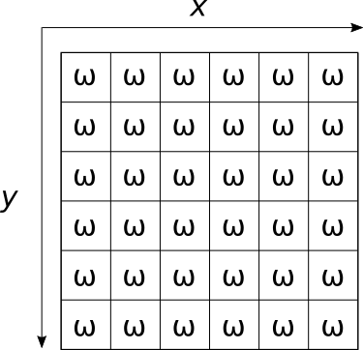

Figure 1: A Visual Depiction of Spatial Frequency Mapping are not they all different omegas?

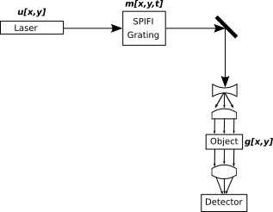

Figure 2: A Simple SPIFI System Setup

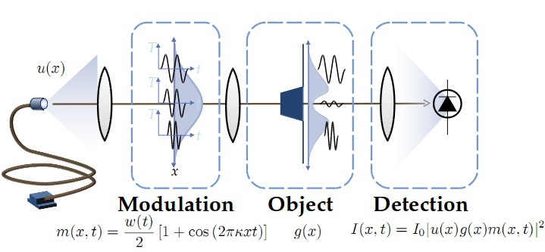

Figure 3: A Graphical Representation of a Simple SPIFI System



Figure 4: Left: A Circular SPIFI Grating - Right: A Rectangular SPIFI Grating

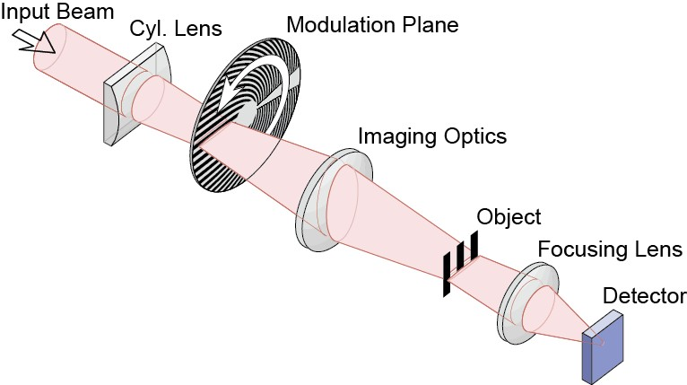

Figure 5: A Simple SPIFI System Using a Circular Grating

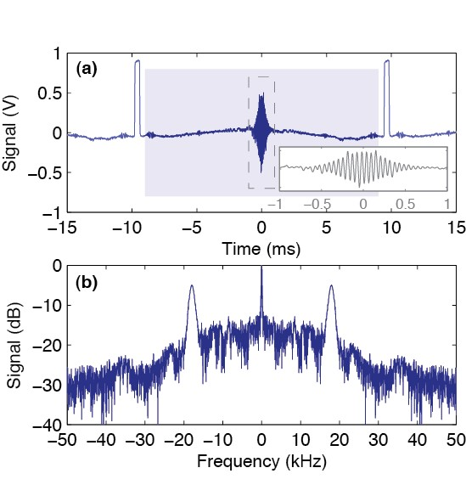

Figure 6: Top: Time-Domain SPIFI Output - Bottom: Corresponding

Frequency-Domain SPIFI Output



Figure 7: Crude Rendering of a Potential 2-Dimensional SPIFI Grating



Figure 8: Possible Pattern for Single Square on 2-Dimensional SPIFI Grating

B Tables/

|  |  |  |  |  |
| --- | --- | --- | --- | --- |
| Item | Unit Cost | Quantity | Unit | Cost |
| 2D Simulation Software  · Labor | $63.00 | 50 | day | $3150.00  $3150.00 |
| Data Collection Suite  · Labor  · Visual Studio License  · Windows 10 Product License  · JetBrains Resharper License | $63.00  $500.00  $120.00  $300.00 | 126  1  1  1 | day ea ea ea | $8858.00  $7938.00  $500.00  $120.00  $300.00 |
| Final Report  · Labor | $63.00 | 0 | day | $0.00  $0.00 |
| · Total Labor  · Overhead | $63.00  50 % of Labor | 176  – | day  – | $11,088.00  $5544.00 |
| Total Cost | What are these ver | tical rules? |  | $17,552.00 |

table titles on top

NOTE: The labor cost of producing the Final Report is accounted for by the time spent working on the Data Collection Suite, because they are to be worked on concurrently (done this way for simplicity).

|  |  |  |  |
| --- | --- | --- | --- |
| Deliverable | Start Date | Duration (Days) | End Date |
| Final Simulator Documentation  1D Data Collection Software Analysis  2D Data Collection Software Data Collection Documentation Final Report | 10/21/16  10/28/16  11/4/17  11/11/16  11/18/16  12/3/16  1/10/17  1/21/17  5/2/17  1/10/17 | 14  7  14  7  22  7  11  115  14  126 | 11/3/16  11/3/16  11/17/16  11/3/16  12/9/16  12/9/16  1/20/17  5/15/17  5/15/17  5/15/17 |

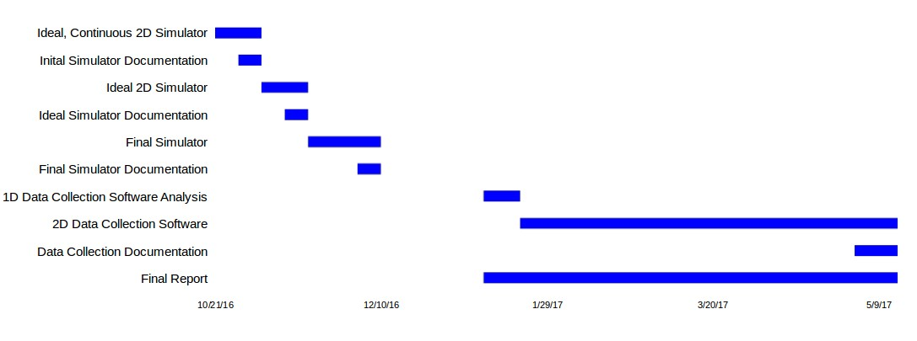

Figure N: Project Timeline

14

C Miscellaneous Information

C.1 Contact Information

• Project Lead: Dr. Jeff Squire, [jsquier@mines.edu](mailto:jsquier@mines.edu)

• Team Head Software Engineer: Brennan W. Fieck, [bfieck@mines.edu](mailto:bfieck@mymail.mines.edu)

C.2 Links

• [2D SPIFI Grating Simulation Software](https://gitlab.com/PiercingGaze/2DSimulator)

• [Data Collection Suite](https://gitlab.com/PiercingGaze/SPIFIDataCollectionSoftware)

• [Original SPIFI Article -](https://www.researchgate.net/profile/Alyssa_Allende_Motz/publication/281058706_Super-resolved_multimodal_multiphoton_microscopy_with_spatial_frequency-modulated_imaging/links/5790535d08ae64311c0c7dbb.pdf?origin=publication_detail&ev=pub_int_prw_xdl&msrp=c3fj9RD45iTpvk8bRBlzYkN6ndcAYlW9SDWsP0gVb8WzFV5pplCJ3WT6D9fQrP2OT3rGfRWxpWECBz07rTxtH3ZWQ-V2CIIn99KlfPF-otY.9HgCklW2b18-KeSg_Y6vX11zOug1uQ3SSCEpbGXSzk5y_fIuZAdBHJtjk82L1NpfpV2e2Cvcd6QBkqBT24bFzQ.uEqPWNYXdN8Ge_jgkDmRdTlNB8rMwiFPPFdueuZQ9VY6c_KOsp-YvgMVBaNkL6Ldag5ifDVuL2YqcNGnICTcHA) hosted by [Research Gate](https://www.researchgate.net)

15